ESO203A_TUT 10 7.4.17

Q1: A synchronous generator is operating from an infinite bus at a constant terminal voltage. The D.C. field current is also kept constant. The synchronous reactance per phase is assumed to be 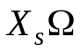.Show that as power output is varied without changing the excitation, the locus of the tip of armature current is a circle. Find the center and radius of the circle.

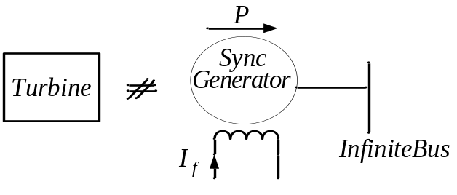

Sol: The per-phase equivalent circuit of the generator is as shown.

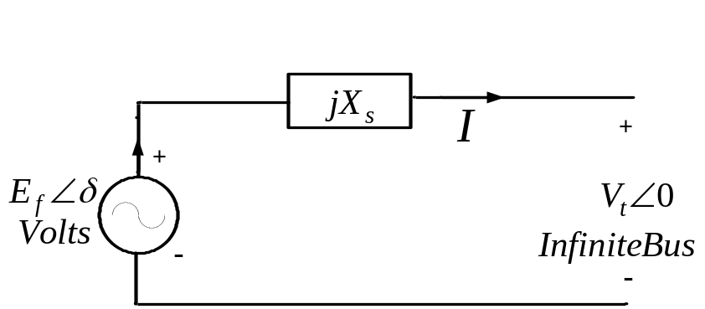

By KVL, 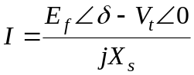 .Thus the phasor is the sum of two terms;

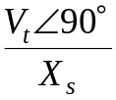 which is fixed and 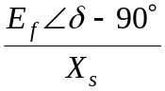 whose phase varies as 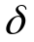 changes while the magnitude is fixed. The locus is thus an arc of a circle with center at 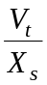 on the y axis and radius equal to 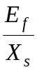.As varies from 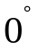 to 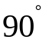,the locus traces a quarter of a circle.

Q2: A 1500 HP 6600V, three phase synchronous motor has an armature current of 136Aand a armature reactance 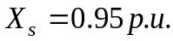Neglect the armature resistance. Let the motor operate from an infinite bus. The input power drawn from the bus is 1000kW.
- Calculate the internal induced e.m.f.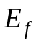, if the power factor is to be adjusted to be unity.
- Calculate the maximum power the motor can deliver if is adjusted to be
1.2 p.u.

Sol: The calculations can be done in the p.u. system. The base values are as follows.

Base power:
The rated power of the motor is 1500HP which equals 1500*0.746=1119kW.So the base for power can be chosen to be 1.119MVA.
Base voltage: The rated voltage of the motor is6600V L-L and 3810.5 L-N. These are the base voltages.
Base current: The base current is 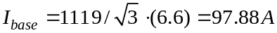.
Base Impedance:
(a)
The machine draws real power P=1000kW=(1000/1119)p.u. The value of X_{s} is given as 0.95p.u.Assume the bus voltage to be 1p.u..From power angle equation,
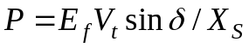.Using p.u. values,
As the power factor is unity,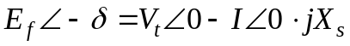.Equating real parts,
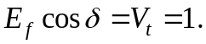
From above equations 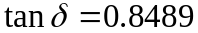 and therefore 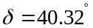.Using this value,
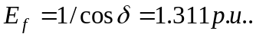
(b) 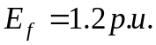 and for maximum power 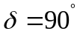.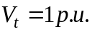
Using , 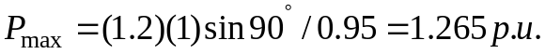

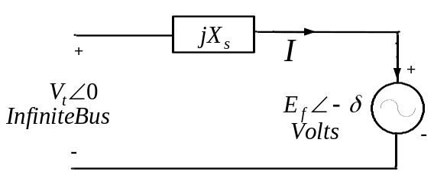

Q3: Figure 1 shows a scheme to transfer power from a 25Hz supply to a 60Hz supply.
The two synchronous machines are mechanically coupled. The idea is to run a synchronous motor from the three phase25Hz supply which acts as a prime-mover for the synchronous generator which generates at frequency of .60Hz

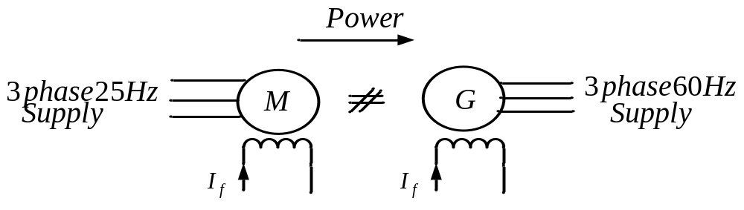
Figure1
Determine the minimum number of poles for the machines. Calculate the speed in RPM of the motor-generator set.

Sol: The machines are mechanically coupled and thus must rotate at the same speed.
Therefore,
And
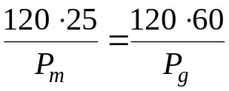 where 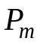and 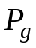 are number of poles of the motor and generator. These numbers must also be even numbers.
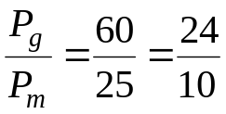.Thus we need a 10 pole motor and a 24 pole generator for this scheme of power conversion from 25 Hz system to 60Hz system. The machines rotate at the speed of 300 RPM.

